90 days ->

Node JS + SQL/NoSQL -> 23 **days**

Node JS:

**Basic Concepts:**

**JavaScript: DAYS [2 day]**

* **Variable hoisting,**
* **Prototype chain – Function prototype, Object Prototype,**
* **bind (), call(), apply()**
* **Closure in JavaScript**
* **All function – map(), filter(), concat(), sort(), every(), some(),includes(), joins(), reduce(), shift(), unshift()**
  + In Built function
    - Object. Keys(), Other functions
    - Process
  + JSON Operation
  + File Operations, File Systems, OS module – multer
  + Global Objects and Functions
  + NODE Events – Single threaded, diagram, multithreading approach, Event Emitter, Global Objects [**1 DAY**]
  + Callback, promises, Promise chaining, async await, Asynchronous Operation. (Callback Hell – How to avoid it) [**1 DAY**]
  + Generator Function [**1 DAY**]
  + Default JavaScript function – SetTimeOut, setInterval (Difference to be asked in Interview) When to use
  + Node JS Buffer
  + Error Handling

**Advanced Topics:**

* Stream [**1DAY**]
* Socket I/O
* Crypto, Encryption, Logging
* API Integration – axios module, [node-fetch](https://www.npmjs.com/package/node-fetch), [**1DAY**]
* Utility Libraries: Utility Libraries
* Security Modules - helmet
* Logging Module – Winston
* Server Creation in Node JS using Express and Other Framework, http. [**1DAY**]
* Caching Techniques – Local Cacheing, Node-cache, Redis [**1DAY**]
* Rest API => Express Js, Morgan, Front End – PUG module. [**9 DAYS**]
  + CURD Operation, Get, Post Put, Delete
  + No SQL DB Integration - M[ongoose](https://mongoosejs.com/), [Sequelize](https://sequelize.org/):
  + 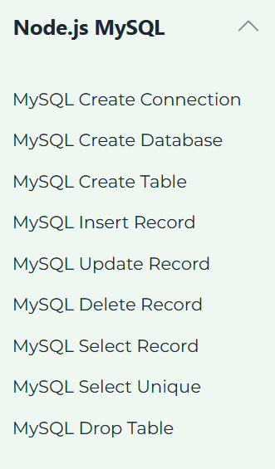
* Authentication: [Passport.js](http://www.passportjs.org/), JSON Web Token (jsonwebtoken), TTS/TLS – Single Signon [**1 DAY**]
* Desing Patterns Module pattern, Single ton, Factory, Observer – More to see [**1 DAY**]
* TDD – Jest, Mocha, Chai, Sinon, Nock. [**1 DAY**]
* PDF Report Generation – pdfkit, puppeteer, xlsx, exceljs, Chart.js (via Node.js wrapper), d3.js (via Node.js), nodemailer [**1 DAY**]
* Load Balancer [**1 DAY**]
* Notification : Twilio, nodemailer, Browser Push Notification, node-schedule [**1 DAY**]
* Performance Monitoring [**1 DAY**]